**LOVELY PROFESSIONAL UNIVERSITY**



**CSE423: VIRTUALIZATION AND CLOUD COMPUTING**

**ASSIGNMENT**

**ON**

“**Upgraded Quality of Internet and 5G Ascent**”

Under the Guidance of

**Ms. Bhanu Talwar**

**Professor**

**Lovely Professional University, Phagwara**

Submitted by,

**Name: Abhimanyu Singh**

**Reg No: 11800740**

**Roll No: B63**

**Section: K17WP**

**Introduction: -**

Pre-5G preliminaries, confirmations of idea, and saint tests have been in the news for longer than a year and which is all well and good. The normal 5G execution jumps over existing 4G LTE is forceful, and really astonishing. In the event that we draw near to the optimistic objectives recorded underneath in genuine use cases, I'll be altogether dazzled.

* Up to 100x higher client data rates
* Up to 100x progressively associated gadgets (for the most part IoT, not people)
* Up to 10x lower dormancy
* Up to 1000x more data volumes

Most news inclusion has been identified with the testing of new 5G wireless advances, for example, flexible waveforms, Massive Multiple Input & Multiple Output (MIMO) antenna arrays, millimetre-wave spread, flexible codecs, new frequency bands, beamforming, and beam tracking. This bodes well, as the initial segments of existing mobile networks to be overhauled will be in the Radio Access System (RAN).

5G New Radios (NR) will be introduced in areas previously lodging 2G, 3G, as well as 4G radios and antennas. Notwithstanding, before wide-scale 5G NR arrangements start, wireless merchants and Mobile Network Operators (MNO) the same must be certain the new wireless advances work dependably and according to particular. The least demanding approach to accomplish this basic stage is to join 5G NRs to existing wireline organize framework previously serving past ages of wireless technology. When 5G NR innovation is demonstrated, wide-scale arrangements will initiate, an extra ordinary life. As a proof point, the GSMA states, "5G systems are conjectured to cover around 33% of the worldwide populace by 2025, with selection arriving at 1.1 billion associations".

5G is the up and coming to age of versatile broadband that will in the long run supplant, or possibly expand, your 4G LTE association. With 5G, you'll see consistently and proportionally quicker download and transfer speeds. Inactivity, or the time it takes gadgets to communicate with wireless networks, will likewise definitely diminish.

**Working: -**

5G systems are computerized cellular networks, in which the service area secured by suppliers is separated into little geological territories called cells. Since we recognize what 5G is, it's a smart thought to see how it functions, since it's unique in relation to conventional 4G LTE. To begin with, how about we talk range(spectrum).

Dissimilar to LTE, 5G works on three distinctive range groups. While this may not appear to be significant, it will dramatically affect your regular use.

* Low-band Spectrum can likewise be depicted as a sub-1GHz range. It's the essential band utilized via transporters in the U.S. for LTE, and data transmission(bandwidth) is almost exhausted. While low-band range offers extraordinary inclusion territory and divider entrance, there is a major disadvantage: Pinnacle information rates will top out around 100Mbps.

T-Mobile is the key player with regards to low-band range. The transporter got an enormous measure of 600MHz range at a Federal Communications Commission (FCC) sell off in 2017 and is utilizing it to rapidly work out it’s across the country 5G organize.

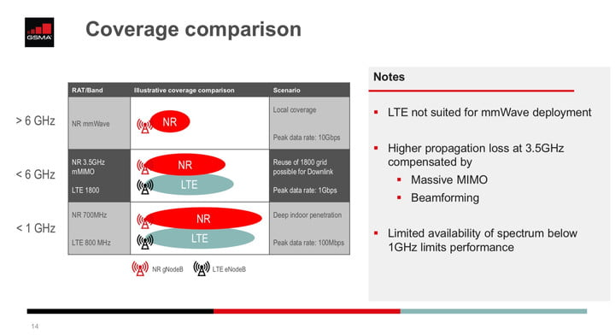

* Mid-band spectrum gives quicker speeds and lower dormancy than low-band. It does, be that as it may, neglect to infiltrate structures as viably as low-band range. Expect top accelerates to 1Gbps on mid-band spectrum.

Spirit has most of unused mid-band range in the U.S. The carrier is utilizing Gigantic MIMO to improve infiltration and inclusion zone on the mid-band. Huge MIMO bunches numerous radio wires onto a solitary box, and at a solitary cell tower, to make various concurrent bars to various clients. Run will likewise utilize Beamforming to reinforce 5G administration on the mid-band. This imparts a solitary centred sign to each client in the phone, and frameworks utilizing it to screen every client to ensure they have a predictable sign.

* High-band spectrum is the thing that conveys the best for 5G, however with significant shortcomings. It is frequently alluded to as mm Wave. High-band range can offer pinnacle accelerates to 10Gbps and has amazingly low inactivity. The principle downside of high-band is that it has low inclusion region and building entrance is poor.

AT&T, T-Versatile, and Verizon are on the whole turning out high-band range. 5G inclusion for the transporters will piggyback off LTE while they work to work out across the nation organizes. Since high-band range penances building infiltration and inclusion territory for fast, it will depend on numerous little cells. These are low-power base stations that spread little geographic zones and can be joined with beamforming to reinforce inclusion.

**How Fast is 5G?**

The International Telecommunication Union (ITU) is a particular organization at the Unified Countries that create specialized guidelines for communication Technologies and it sets the standards for radio-spectrum utilization and broadcast communications interoperability. In 2012, the ITU made a program called "IMT for 2020 and past" (IMT-2020) to inquire about and build up least prerequisites for 5G. Following quite a while of work, the office made a draft report with 13 Least prerequisites for 5G in 2017.

When the ITU set the base necessities for 5G, the third-generation partnership project (3GPP), a coordinated effort of broadcast communications principles associations, started dealing with making norms for 5G. In December 2017, 3GPP finished its non-standalone (NSA) determinations, and in June 2018 it caught up with its stand-alone particulars (SA).

Both NSA and SA norms share similar determinations, however NSA utilizes existing LTE systems for rollout while SA will utilize a cutting-edge center system. Bearers are beginning with the NSA detail, which implies you will depend on 4G LTE in a non-5G condition.

The principles set by 3GPP intently compare with IMT-2020 execution targets and are fairly unpredictable, yet here's a general summary:

* **Peak Data rate**: 5G will offer altogether quicker information speeds. Peak Data rates can hit 20Gbps downlink and 10Gbps uplink per versatile base station. Brain you, that is not the speed you'd involvement in 5G (except if you have a committed association) — it's the speed shared by all clients on the cell.
* **Real-world speeds**: While the peak data rates for 5G sound truly great, real speeds won't be the equivalent. The spec calls for client download paces of 100Mbps and transfer rates of 50Mbps.
* **Latency:** Latency, the time it takes information to go starting with one point then onto the next, ought to be at 4 milliseconds in perfect conditions, and at 1 millisecond for use cases that request the most extreme speed. Think remote medical procedures, for example.
* **Efficiency:** Radio interfaces ought to be vitality proficient when being used and drop into low-vitality mode when not being used. Preferably, a radio ought to have the option to switch into a low-vitality state inside 10 milliseconds when not, at this point being used.
* **Spectral efficiency:** Otherworldly productivity is "the advanced utilization of range or transfer speed so the greatest measure of information can be transmitted with the least transmission mistakes." 5G ought to have somewhat improved unearthly effectiveness over LTE, coming in at 30bits/Hz downlink, and 15 bits/Hz uplinks.
* **Portability:** With 5G, base stations should bolster development from 0 to 310 mph. This implies the base station should work over a scope of receiving wire developments — even on a rapid train. While it's effectively done on LTE systems, such versatility can be a test on new millimeter wave systems.
* **Connection Density:** 5G ought to have the option to help a lot of more associated gadgets than LTE. The standard states 5G ought to have the option to help 1 million associated gadgets for each square kilometer. That is an immense number, which considers the huge number of gadgets that self-control the Web of Things (IoT).

**What 5G can do?**

**Improve broadband:**

The move to 5G will without a doubt changes the manner in which we communicate with innovation on an everyday premise, but at the same time it's a flat out need on the off chance that we need to keep utilizing mobile broadband.

Bearers are coming up short on LTE limit in many significant metropolitan regions. In certain urban areas, clients are as of now encountering stoppages during active times. 5G includes enormous measures of range in groups that haven't been utilized for business broadband traffic.

**Self-governing vehicles:**

Hope to see self-governing vehicles ascend at a similar rate that 5G is sent over the U.S. Later on, your vehicle will speak with different vehicles out and about, give data to different vehicles about street conditions, and offer execution data to drivers and automakers. In the event that a vehicle slows down rapidly up ahead, yours may find out about it promptly and preemptively brake also, forestalling an impact. This sort of vehicle-to-vehicle correspondence could at least spare a huge number of lives.

**Public Safety and Infrastructure:**

5G will permit urban communities and different districts to work all the more productively. Service organizations will have the option to handily follow utilization remotely, sensors can advise opening works divisions when channels flood or streetlights go out, and districts will have the option to rapidly and modestly introduce observation cameras.

**Remote gadget control:**

Since 5G has amazingly low inertness, remote control of overwhelming apparatus will turn into a reality. While the essential point is to lessen the chance in dangerous situations, it will likewise permit professionals with particular aptitudes to control hardware from anyplace on the planet.

**Health Care:**

The ultra-reliable low-latency communications (URLLC) segment of 5G could on a very basic level change medicinal service. Since URLLC diminishes 5G dormancy much farther than what you'll see with upgraded portable broadband, a universe of additional opportunities opens up. Hope to see upgrades in telemedicine, remote recuperation, and non-intrusive treatment by means of AR, exactness medical procedure, and even remote medical procedure in the coming years.

Remember massive Machine-Type Communications? mMTC will likewise assume a key job in social insurance. Medical clinics can make huge sensor systems to screen patients, doctors can recommend savvy pills to follow consistence and back up plans can even screen supporters to decide suitable medicines and procedures.

**IoT:**

One of the most energizing and vital parts of the 5G is its impact on the Internet of Things. While we as of now have sensors that can speak with one another, they will in general require a great deal of assets and are rapidly draining LTE data limit.

With 5G speeds and low latencies, the IoT will be fueled by correspondences among sensors and savvy gadgets (here's mMTC once more). Contrasted with current brilliant gadgets available, mMTC gadgets will require less assets, since colossal quantities of these gadgets can interface with a solitary base station, making them significantly more proficient.

**IoT and AI Revolution: -**

To see the most highlighted potential outcomes that exist in 5G it might be fascinating to take a gander at a couple of the on-screen characters that have a lot to pick up from its extension, for example, Samsung. In a news story composed by Samsung on the 28th of October 2019 there is a depiction of the IoT and AI Revolution.

This article guarantees that 5G availability will permit various answers for get to more information ongoing which will make arrangements altogether different. 5G utilizes 'far less force', utilizing IoT sensors that can keep going for a year. Inside cultivating altering water system levels and in assembling inside manufacturing plants set to recognize when the state of gear changes.

There is notwithstanding this the likelihood to cut out various uses for specialists to make sure about treatment of patient information. The article states:

**"5G is up to multiple times quicker than 4G. However, this most recent age of systems is not really simply 'quicker 4G.' Coupled with record-setting low inactivity, 5G's paces will permit designers to make applications that benefit as much as possible from improved response times, for example, close to constant video transmission for games or security purposes."**

**Be that as it may, is it a Race?**

As called attention to recently there has been an incredible exertion by the organizations needing to extend 5G association with outline the opposition as a race. Here is a whole microsite from industry campaigning bunch CTIA titled "The Race to 5G." There are not kidding exchange offs in the range and they are being disregarded because of the speed the sending is being made.

"What's more, once the 'race' to work out 5G in enormous urban areas is 'won,' the strain to extend access to different places in the nation will evaporate, aggravating that gap even. It is worth cautiously thinking about these things before surrendering to flurry."

Hence, we ought not escape with this 'race' and be heedless to conceivable unfriendly outcomes that this development may bring.

Man-made reasoning and 5G Robotics.

**The Speed that May Enable Further Usage of Robotics and AI:**

On the off chance that we ignore the ecological harm that AI and Robotics could cause considering the substantial asset necessity it has, let us consider what it really could do. Telephone organizations and broadcast communications tout the astounding new things you can do with your telephone should you have the option to 'up your speed' or carry it to the following level. In any case, believe it or not what might you do? Very little more than previously. Gushing is now working rather well, and you can play candy crush and so forth. However, we didn't envision what we would do with this sort of speed or network before it showed up. Everybody, or a great many people, sitting with their eyes stuck to a telephone on open transportation. The open spaces loaded up with individuals that are some way or another cluelessly strolling with their telephone loosened up before them to explore, read, play or associate in a hurry. Past your quick use there are a few use cases in industry we ought to know about.

**Artificial Intelligence Combined With 5G Robotics:**

One thing that is sure is that this kind of innovation may empowers apply autonomy in an alternate manner and 'keen' robots to work inside a more extensive condition. We can promptly consider the all-encompassing unfavourable utilization of this for guard purposes and observing a populace. Anyway, then again inside emergency clinics and wellbeing innovation this may empower an alternate workplace or follow-up by mechanical creations.

Running arrangements identified with the field of man-made reasoning is done remotely as of now so will you genuinely see a distinction? On the off chance that the video, content or other articulation/input is moved to a better place — at that point what is the distinction for clients. It very well may be trying to perceive how this would help, and AI use-cases were referenced in a past article. Utilizing AI methods in 5G system to improve the utility in the radio range which is dispensed. As of now it appears as:

* Self-driving self-ruling vehicles,
* Mechanizing or overseeing open transportation,
* Time-basic industry mechanization,
* Remote human services

These are for the most part regions where equipment and programming will empower changes in tasks. Obviously process robotizations are as of now impacting working existence with information from laborers being checked just as execution estimated. Anyway, the robots that can work in human services, transport and industry will probably be improved by these new innovations in IoT.

**Blockchain, 5G Robotics and AI:**

Anyway, much this title resembles a popular expression bingo there is something to be said for the security need required by these new sorts of arrangements. Considering the subject of who works in this IoT region we can contend that entertainers, for example, IOTA will see a lot of development proceeding.

**“Our vision is to empower every single associated gadget through confirmation of truth and value-based settlements which boost gadgets to make accessible its properties and information progressively. This brings forth totally new broadly useful applications and worth chains**.**”**

In this way I think with the necessary security in these headways’ organization entertainers, for example, IOTA will be important to make it work or if nothing else ready to work.

**Sustaining 5G Robotics and AI:**

As referenced in the presentation we should genuinely scrutinize this progression, we can't keep running into 'innovation' and 'headway' while putting two hands up to our ears. In the event that we disregard the possibly antagonistic outcomes of the previously mentioned trendy expression bingo we are in a difficult situation. Vitality and asset necessities by spilling AI to intensely encoded 5G systems sounds totally crazy, is it even faultless to do as such?

**Models of AI Used for the 5G Applications: -**

1. **Supervised Learning**: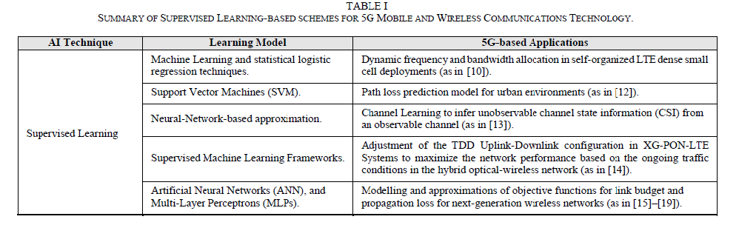
2. **Unsupervised Learning**:

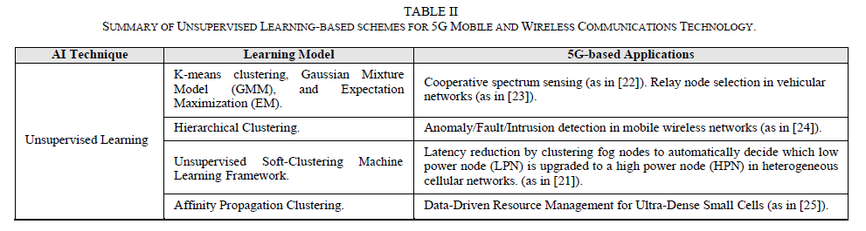

1. **Reinforcement Learning:**

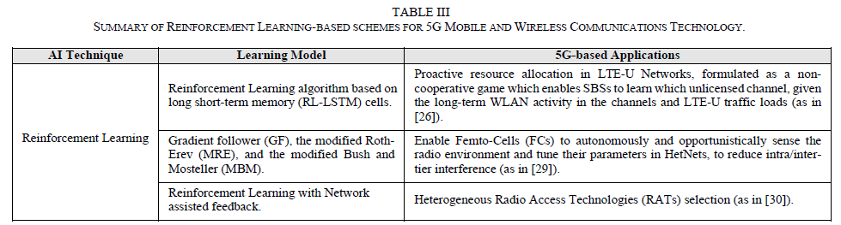

**EU's International Security Policy, Artificial Intelligence and 5G: -**

* **Increased Connectivity and Emerging Risks:**

On the ninth of October 2019 TechCrunch composed an article about another joint hazard evaluation report into 5G innovation. So far, the European Union has opposed strain to blacklist Huawei as a 5G provider on national security grounds. In March 2019 US recommended that EU should square Huawei from getting to its market. The report recognizes "security challenges" bound to show up in 5G systems.

" An expanded presentation to assaults and progressively potential section focuses for aggressors: With 5G organizes progressively dependent on programming, dangers identified with significant security blemishes, for example, those getting from poor programming improvement forms inside providers are picking up in significance."

Certain hardware is turning out to be progressively delicate, for example, base stations or the executive’s capacities in systems. Dependence of portable system administrators on providers may prompt a higher number of 'assault ways'. These can be abused by risk entertainers. Non-EU States or State-upheld are considered as the most genuine ones and the well on the way to target 5G systems. Hazard profile of individual providers will get significant. There is a danger of significant conditions on providers. Reliance can introduce a high level of hazard. Danger to accessibility and trustworthiness just as security and classification. As per TechCrunch the subsequent stage will be: "… the turn of events, by December 31, of a tool kit of relieving measures, concurred by the Network and Information Systems Cooperation Group, which will be planned for tending to recognized dangers at national and Union level."

"The suggestion is that the matter of 5G security should get proportionately enormous to scale to meet the multi-dimensional security challenge that goes submit glove with the cutting-edge tech. Simply restricting a solitary provider won't cut it."

* **Best British Tech Start-ups in 5G:**

KPMG has an opposition for new businesses and inside this I have seen progressions (I work with KPMG). I will list two of the new companies referenced in this opposition:

Army Technology have spearheaded an inventive security stage to counter the danger of industrious and focused on assaults, which misuse corporate web availability. David Garfield, CEO at Garrison Technology, discloses to us more in his meeting underneath.

SenSat Technology utilizes recreated real factors of major urban zones to extricate noteworthy bits of knowledge utilizing AI methods. This diminishes the rollout cost for broadcast communications organizations for 5G and eventually, the expense of 5G for purchasers.

Security stages is turning out to be significant particularly when the rollout of 5G handles delicate information. Utilizing AI to improve these correspondences will be basic for mechanical technology to be functioning admirably.

As indicated by the security report: "… thought ought to likewise be given to the improvement of the European modern limit as far as programming advancement, hardware fabricating, research facility testing, similarity assessment, and so on" Therefore we can expect greater venture either into the mechanical extension in EU with respect to 5G or a lot of speculation into 5G security over the coming years.

**Fitbit + Google AI + 5G =?**

Google Buys Fitbit for $2.1 billion. An article in the Verge distributed the first of November 2019 declared the acquisition of Fitbit by Google:

Google has recently declared that it's purchasing wearable organization Fitbit for $2.1 billion. In a blog entry declaring the news, Google SVP of gadgets and administrations Rick Osterloh said that the Fitbit buy is "a chance to put much more in Wear OS just as present Made by Google wearable gadgets into the market."

This can be an unpredictable speculation, yet I have seen a couple of various contentions as far as why this procurement was made:

* Google needs to put resources into wearables and didn't figure out how to create arrangements practical enough all alone. It is subsequently purchasing FitBit to take into account this contribution.
* Google is purchasing FitBit for exclusive innovation.
* Google has purchased FitBit for its information — not to build promotions, yet to aid its interest in wellbeing innovation (which makes up huge pieces of the Alphabet portfolio).

There are likely more reasons, anyway there has all the earmarks of being a solid mindfulness by the alarm towards buyer as far as securing their wellbeing information. The announcement straightforwardly from FitBit on the first of November said the accompanying:

**"Buyer trust is central to Fitbit. Solid protection and security rules have been a piece of Fitbit's DNA since the very first moment, and this won't change. Fitbit will keep on placing clients in charge of their information and will stay straightforward about the information it gathers and why. The organization never sells individual data, and Fitbit wellbeing and health information won't be utilized for Google advertisements."**

Rick Osterloh, Senior Vice President, Devices and Services at Google. Said they would unite the ability from FitBit in equipment together with programming and man-made reasoning to fabricate better wearables.

This happens at the same time as Alphabet which claims Google is growing its interests in Verily and Calico. These are two organizations which are more than once referenced in Alphabet Inc's quarterly explanations. Wellbeing information is an interesting issue.

In spite of the fact that Google may not utilize FitBit information for advertisements it could utilize that amassed information for medicate improvement or experiences for wellbeing in Verily and Calico. What stops Google/Alphabet from doing as such?

I have brought a portrayal from the third quarterly (Q3) for 2019 page of Alphabet's financial specialist relations page. The accompanying two segments are selections from Q3.

**Calico: -**

Calico is a real existence science organization with a crucial bridle trend setting innovations to build our comprehension of the science that controls life expectancy.

In September 2014, AbbVie Inc. (AbbVie) and Calico went into an innovative work joint effort understanding planned to enable the two organizations to find, create, and bring to showcase new treatments for patients with age-related infections, including neurodegeneration and malignancy. In the second quarter of 2018, AbbVie and Calico revised the joint effort understanding bringing about an expansion in complete responsibilities. As of September 30, 2019, AbbVie has contributed $750 million to support the joint effort according to the understanding and is focused on an extra $500 million which will be paid by the final quarter of 2019. As of September 30, 2019, Calico has contributed $500 million and has submitted up to an extra $750 million.

Calico has utilized its logical ability to set up a world-class innovative work office, with an emphasis on medicate disclosure and early medication advancement; and AbbVie gives logical and clinical improvement backing and its business mastery to put up new revelations for sale to the public. The two organizations share expenses and benefits for ventures secured under this understanding similarly. AbbVie's commitment has been recorded as a risk on Calico's budget reports, which is diminished and reflected as a decrease to innovative work cost as qualified innovative work costs are acquired by Calico.

As of September 30, 2019, we have contributed $480 million to Calico in return for Calico convertible favoured units and are resolved to subsidize up to an extra $750 million dependent upon the situation and subject to specific conditions.

**Verily: -**

Verily is a real existence science organization with a strategic make the world's wellbeing information helpful so individuals appreciate more beneficial lives. In December 2018, Verily got $900 million in real money from a $1.0 billion speculation round. The remaining $100 million was gotten in the primary quarter of 2019. As of September 30, 2019, Verily has gotten a total measure of $1.8 billion from deals of value protections to outside speculators. These exchanges were represented as value exchanges and no addition or misfortune was perceived.

**Conclusion: -**

In the wake of investigating a portion of the effective situations where AI is utilized as an instrument to improve 5G innovations, we emphatically accept that the combination between these two information skills will have a huge effect in the advancement of group of people yet to come systems. The period where remote systems analysts were hesitant to utilize AI-based calculations because of the absence of comprehension of the counterfeit learning process, has been left before. These days, with the force and pervasiveness of data, various analysts are adjusting their insight and extending their devices weapons store with AI-based models, calculations and practices, particularly in the 5G world, where even a couple of milliseconds of inertness can have any kind of effect. A solid 5G framework requires incredibly low dormancy, which is the reason not all things can be put away in remote cloud servers far away. Inertness increments with separation and clog of system joins. Base stations have restricted capacity size, so they need to figure out how to anticipate client needs by applying an assortment of man-made reasoning devices. With these devices, each base station will have the option to store a decreased yet satisfactory arrangement of records or substance. This is one model why our future systems must be prescient, and how Artificial Intelligence gets significant in enhancing this sort of issues in the system. An extra objective of connecting AI with 5G systems is acquire noteworthy upgrades with regards to edge reserving just by applying off-the-rack AI calculations. We have indicated how AI can be an answer that can fill this hole of necessities in 5G versatile and remote interchanges, permitting base stations to foresee what sort of substance clients close by may demand sooner rather than later, distributing dynamic frequencies in self-composed LTE thick little cell arrangements, anticipating way misfortune/connect spending plan with approximated NN models, deriving the undetectable channel state data from a recognizable channel, changing the TDD uplink-downlink design in XG-PON-LTE frameworks dependent on continuous system conditions, detecting the range utilizing unaided models, diminishing the inactivity via consequently designing the groups in Het-Nets, distinguishing oddities/deficiencies/interruptions in portable remote systems, dealing with the assets in ultra-thick little cells, choosing the hand-off hubs in vehicular systems, apportioning the assets in LTE-U systems, empowering self-governing and deft detecting of the radio condition in femto-cells, choosing the ideal radio access innovation (RAT) in HetNets, among others.